Aim: To implement a weather application using Flask that retrieves and displays weather information based on user input.

Q1. What is Flask?
Flask is a lightweight and flexible micro web framework for Python. It provides tools, libraries, and patterns to build web applications and APIs with minimal code. Unlike full-stack frameworks, Flask keeps the core simple but is highly extensible with extensions for databases, authentication, etc.

Q2. What is an API?
API stands for Application Programming Interface. It is a set of rules and protocols that allows different software applications to communicate with each other. In web development, a Web API (often RESTful) exposes endpoints (URLs) that accept requests (e.g., GET, POST) and return data (commonly JSON or XML) without a graphical user interface.

Q3. What is the purpose of a virtual environment?
A virtual environment is an isolated Python environment that allows you to manage project-specific dependencies without interfering with system-wide Python packages. Its main purposes are:
- Avoid version conflicts between projects.
- Keep global Python clean and minimal.
- Reproduce the exact environment across development, testing, and production (e.g., via requirements.txt).

Q4. What is HTTP GET method?
The GET method is one of the HTTP request methods used to retrieve data from a server. It appends parameters to the URL (query string) and should be idempotent (repeating the same request has the same effect) and safe (does not change server state). Examples: loading a webpage, fetching search results, or calling an API endpoint to read data.

Q5. How does a web application handle user input?
- Capture input via HTML forms, JavaScript events, or URL parameters.
- Send to server using an HTTP request (GET with query params, POST/PUT with form data or JSON in the request body).
- Validate and sanitize on the server to prevent security issues (e.g., SQL injection, XSS).
- Process the data (e.g., save to a database, perform calculations).
- Generate a response (HTML page, redirect, or JSON data) sent back to the client.
- Provide feedback to the user (success/error messages, updated UI).

Q6. Implement a weather application using Flask that retrieves and displays weather information based on user input.
Code (app.py):
from flask import Flask, render_template, request
import requests
from datetime import datetime

app = Flask(__name__)

API_KEY = "efa2f42bad1530ef4a494f012912c0ac"
BASE_URL = "https://api.openweathermap.org/data/2.5/weather"

@app.route('/', methods=['GET', 'POST'])
def index():
weather = None
error = None

if request.method == 'POST':
city = request.form['city']

params = {
'q': city,
'appid': API_KEY,
'units': 'metric'
}

response = requests.get(BASE_URL, params=params)
data = response.json()

print(data)

if str(data.get("cod")) != "200":
error = data.get("message", "Error fetching data")
else:
sunrise_time = datetime.fromtimestamp(data['sys']['sunrise']).strftime('%H:%M:%S')
sunset_time = datetime.fromtimestamp(data['sys']['sunset']).strftime('%H:%M:%S')
data_time = datetime.fromtimestamp(data['dt']).strftime('%Y-%m-%d %H:%M:%S')

weather = {
'temperature': data['main']['temp'],
'feels_like': data['main']['feels_like'],
'description': data['weather'][0]['description'],
'weather_main': data['weather'][0]['main'],
'humidity': data['main']['humidity'],
'pressure': data['main']['pressure'],
'wind': data['wind']['speed'],
'city': data['name'],
'country': data['sys']['country'],
'last_updated': data_time,
'sunrise': sunrise_time,
'sunset': sunset_time
}

return render_template('index.html', weather=weather, error=error)

if __name__ == '__main__':
app.run(debug=True)
Code (root_layout.html):

<!doctype html>
<html>
<head>
<title>Weather App</title>
</head>

<body>
<div class="container">
<div class="search-section">
<form method="POST" class="input-group">
<input
type="text"
name="city"
placeholder="Enter city name (e.g., London, Tokyo, New York)"
required
/>
<button type="submit">🔍 Get Weather</button>
</form>
</div>

<div class="weather-grid">
{% if error %}
<div class="error-message">⚠️ {{ error }}</div>
{% endif %} {% if weather %}

<div class="weather-card city-card">
<div class="city-name">{{ weather.city }}</div>
<div class="country-name">{{ weather.country }}</div>
<div class="temp-large">{{ weather.temperature }}°C</div>
<div class="card-description">
{{ weather.description | capitalize }}
</div>
</div>

<div class="weather-card">
<div class="card-header">
<span class="icon">🤔</span>
<h3>Feels Like</h3>
</div>
<div class="card-value">
{{ weather.feels_like }}<span class="card-unit"
>°C</span
>
</div>
<div class="card-description">Real feel temperature</div>
</div>

<div class="weather-card">
<div class="card-header">
<span class="icon">📊</span>
<h3>Category</h3>
</div>
<div class="card-value">{{ weather.weather_main }}</div>
<div class="card-description">Weather type</div>
</div>

<div class="weather-card">
<div class="card-header">
<span class="icon">💧</span>
<h3>Humidity</h3>
</div>
<div class="card-value">
{{ weather.humidity }}<span class="card-unit">%</span>
</div>
<div class="card-description">Moisture level</div>
</div>

<div class="weather-card">
<div class="card-header">
<span class="icon">📈</span>
<h3>Pressure</h3>
</div>
<div class="card-value">
{{ weather.pressure }}<span class="card-unit">hPa</span>
</div>
<div class="card-description">Atmospheric pressure</div>
</div>

<div class="weather-card">
<div class="card-header">
<span class="icon">🌬️</span>
<h3>Wind Speed</h3>
</div>
<div class="card-value">
{{ weather.wind }}<span class="card-unit">m/s</span>
</div>
<div class="card-description">Wind intensity</div>
</div>

<div class="weather-card">
<div class="card-header">
<span class="icon">🌅</span>
<h3>Sunrise</h3>
</div>
<div class="card-value">{{ weather.sunrise }}</div>
<div class="card-description">Morning begins</div>
</div>

<div class="weather-card">
<div class="card-header">
<span class="icon">🌇</span>
<h3>Sunset</h3>
</div>
<div class="card-value">{{ weather.sunset }}</div>
<div class="card-description">Evening falls</div>
</div>

<div class="weather-card">
<div class="card-header">
<span class="icon">🕐</span>
<h3>Last Updated</h3>
</div>
<div class="card-value" style="font-size: 20px">
{{ weather.last_updated }}
</div>
<div class="card-description">Data freshness</div>
</div>
{% endif %}
</div>
</div>
</body>
</html>

Output:

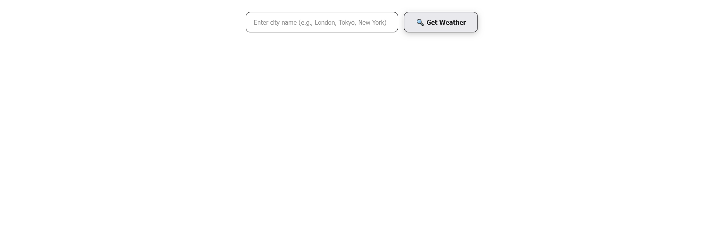

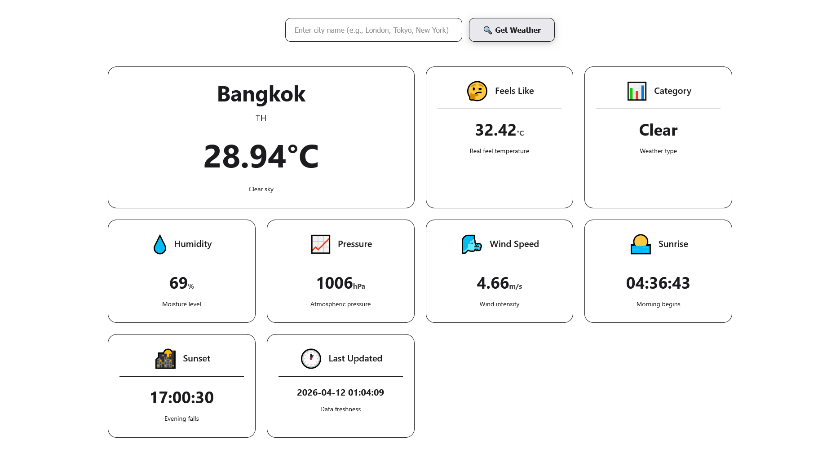

Conclusion:
Successfully implemented a weather application using Flask that retrieves and displays weather information based on user input.

